**Setup Sonarqube using Docker and Docker compose and integration with Gitlab**

**- Installing Docker Compose on CentOS:**

1)install Docker Compose from the binary in Docker’s GitHub repository

-sudocurl-L"https://github.com/docker/compose/releases/download/1.23.2/docker-compose-$(uname -s)-$(uname -m)" -o /usr/local/bin/docker-compose

2)set the permissions to make the binary executable

- sudo chmod +x /usr/local/bin/docker-compose

3)verify the status and version

- docker-compose --version

Create docker-compose.yml:

That yml file has all configuration for installing SonarQube and Postgresql

1)Create the directory

- mkdir sonarqube

2)Create the docker-compose.yml file

- sudo vi docker-compose.yml

3)Copy the below code inside the file

version: "3"

services:

sonarqube:

image: sonarqube:lts

container_name: sonarqube

restart: unless-stopped

environment:

- SONARQUBE_JDBC_USERNAME=sonar

- SONARQUBE_JDBC_PASSWORD=password123

- SONARQUBE_JDBC_URL=jdbc:postgresql://db:5432/sonarqube

ports:

- "9000:9000"

- "9092:9092"

volumes:

- sonarqube_conf:/opt/sonarqube/conf

- sonarqube_data:/opt/sonarqube/data

- sonarqube_logs:/opt/sonarqube/logs

- sonarqube_extensions:/opt/sonarqube/extensions

- sonarqube_bundled-plugins:/opt/sonarqube/lib/bundled-plugins

db:

image: postgres:latest

container_name: db

restart: unless-stopped

environment:

- POSTGRES_USER=sonar

- POSTGRES_PASSWORD=password123

- POSTGRES_DB=sonarqube

volumes:

- sonarqube_db:/var/lib/postgresql10

- postgresql_data:/var/lib/postgresql10/data

volumes:

postgresql_data:

sonarqube_bundled-plugins:

sonarqube_conf:

sonarqube_data:

sonarqube_db:

sonarqube_extensions:

sonarqube_logs:

4)Save the file

- By entering :wq!

5)Execute the compose file using Docker compose command

- sudo docker-compose up -d

6)To check the status of SonarQube is up and running

- sudo docker-compose logs --follow

7)To access sonarQube UI

- http://<IP_address>:9000

To get the following output

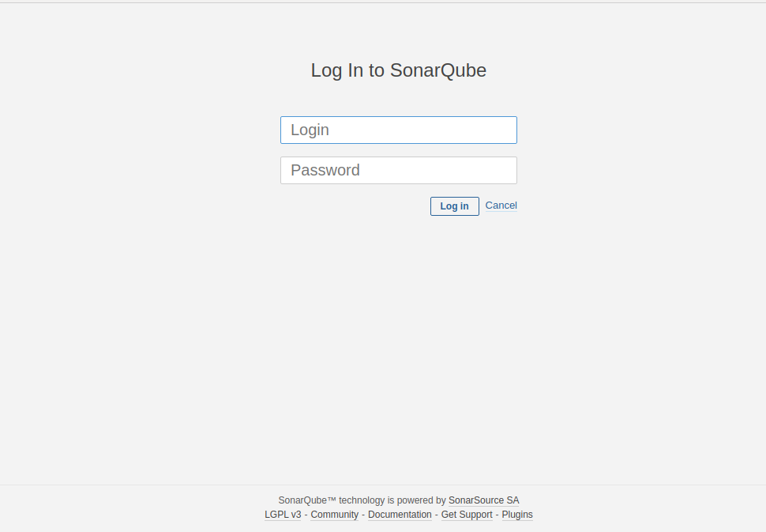

**SonarQube with GitLab integration:-**

**-** Provide the Credentials of sonarqube

- Inside the sonarqube dashboard select to create the new project

- Provide the project key and display name and click on setup

- To generate the token provide the name of token and click on generate token

- Copy the token and save it we use that in scanner.js file

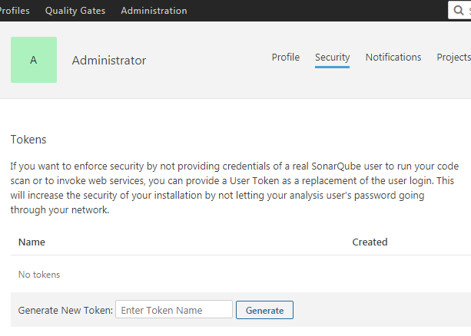

**Install the Nodejs and JDK**

**-** Inside the server install the nodejs and jdk using following commands

For nodejs-

- curl -sL https://rpm.nodesource.com/setup_10.x | sudo bash -

- sudo yum install nodejs

- node --version

For jdk-

- sudo yum install java-11-openjdk-devel

- java –version

**Creation of scanner.js file:-**

- Inside the server create the scanner.js file on the location where our source code is present

- sudo nano scanner.js

- paste the following and save the file

const scanner = require("sonarqube-scanner");

scanner({

serverUrl : '<Url_of_sonarqube>',

token : "<Provide the token that created in last step>",

options: {

"sonar.projectKey": "<provide the key name use in token creation time>",

"sonar.sources": "Path_Bundle1,path_Bundle2"

},

},

() => {

// callback is required

}

);

- After that provide the commands

- sudo npm i -g sonarqube-scanner

- execute js file like "node scanner.js"

- All the files are scanning one by one and push the code in the sonarqube create project

- To get the status as passed and details about the bugs, Coverage etc. on the dashboard.